**Business Requirements Document - Pngr**



Hunter Davis

Oscar Gepiga

Tymee Kong

Tanner Mindrum

Shihong Sun

Ping Piratez

CECS 491A

Jean Tsao

2/12/2020

**Table of Contents:**

Preface…………………………………………………………………………………………...3

Strategy…………………………………………………………………………………………..3

Market Segments………………………………………………………………………………..4

Primary Market Research……………………………………………………………………...4

Secondary Market Research…………………………………………………………………..8

Case Study “Ask Around” App……………………………………………………………….11

Data Driven Decisions………………………………………………………………………...12

User Need……………………………………………………………………………..……….13

Competitors…………………………………………………………………………...………..13

SWOT (Strength, Weaknesses, Opportunities, Threats)................................................14

Appendix…………...…………………………………………………………………………...15

Sources…………………………………………………………………………………………17

**Preface:**

We are interested in this project primarily because it solves a common problem we run into on a weekly/daily basis for the target demographic that includes us, which is young, busy college students. Our particular customer need is the ability to see the availability and status of friends and people in groups to meet up or study together. Another need is the ability to not be bothered while working or studying in order to avoid distractions, which all of us face while trying to be productive. This project will also allow users to share hotspot locations of places to check out or events happening nearby.

Our technological innovation and depth is open broadcasted communication between friends and groups in order to provide transparency between a user’s friends and social circles. Our mobile app will be intuitive, quick, and efficient in delivering this information while providing location-based data to users. We will be building an Android application using Java, Google Maps API, a machine learning implementation with sentiment analysis, and using a database in MySQL.

**Strategy**:

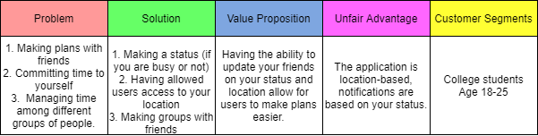

**Market Segments**:

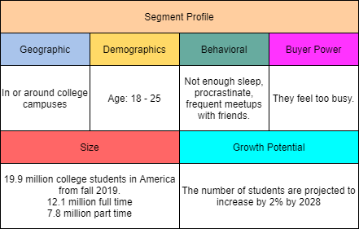

**Primary Market Research**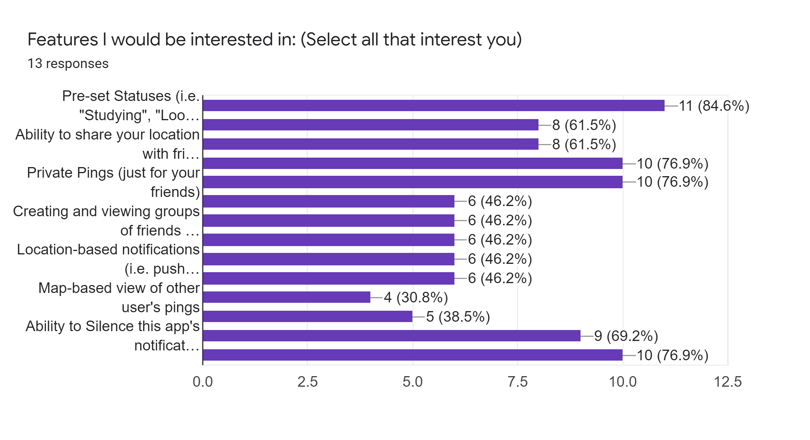

Above: Raw Data from Google Survey Results with number of users and percentage per answer

Questions: Features I would be interested in: (Select all that interest you)

1. Pre-set Statuses (i.e. "Studying", "Looking to hang", "Working", "Chilling")
   1. 11 (84.6%)
2. Custom Statuses (i.e. user enters their own status)
   1. 8 (61.5%)
3. Ability to share your location with friends
   1. 8 (62.5%)
4. Ability to chat with friends via the app
   1. 10 (76.9%)
5. Private Pings (just for your friends)
   1. 10 (76.9%)
6. Public Pings (visible to any user nearby)
   1. 6 (46.2%)
7. Creating and viewing groups of friends (statuses)
   1. 6 (46.2%)
8. Ability to notify any non-busy users within a group
   1. 6 (46.2%)
9. Location-based notifications (i.e. push notification if a friend or other user marks a hotspot near you)
   1. 6 (46.2%)
10. Map-based view of friends
    1. 6 (46.2%)
11. Map-based view of other user's pings
    1. 4 (30.8%)
12. Notifications based on nearby friends' status changes (i.e. a friend within a mile changes their status to "Looking to hang" from "Studying")
    1. 5 (38.5%)
13. Ability to Silence this app's notifications based on your status (i.e. while "Studying" or "Working" status is active)
    1. 9 (69.2%)
14. Ability to pre-set busy times (i.e. class or work schedule to silence notifications)
    1. 10 (76.9%)

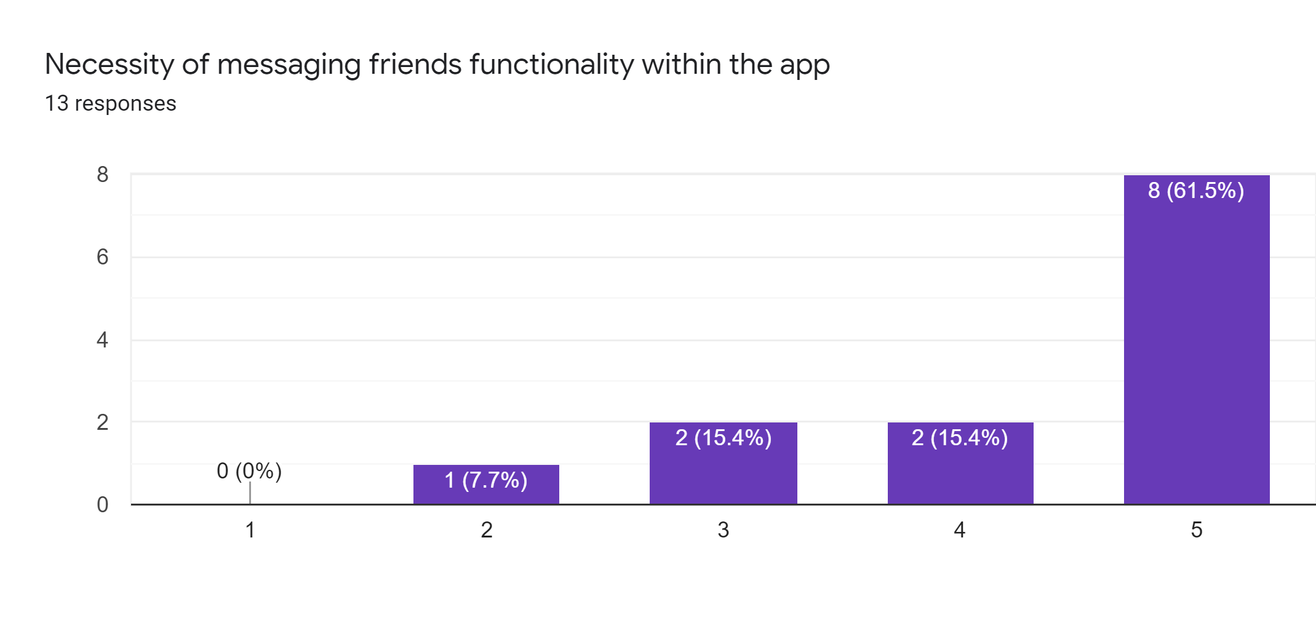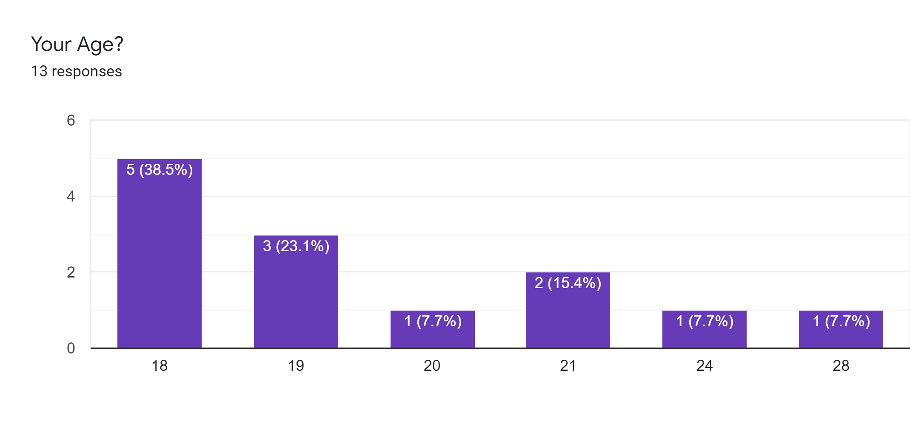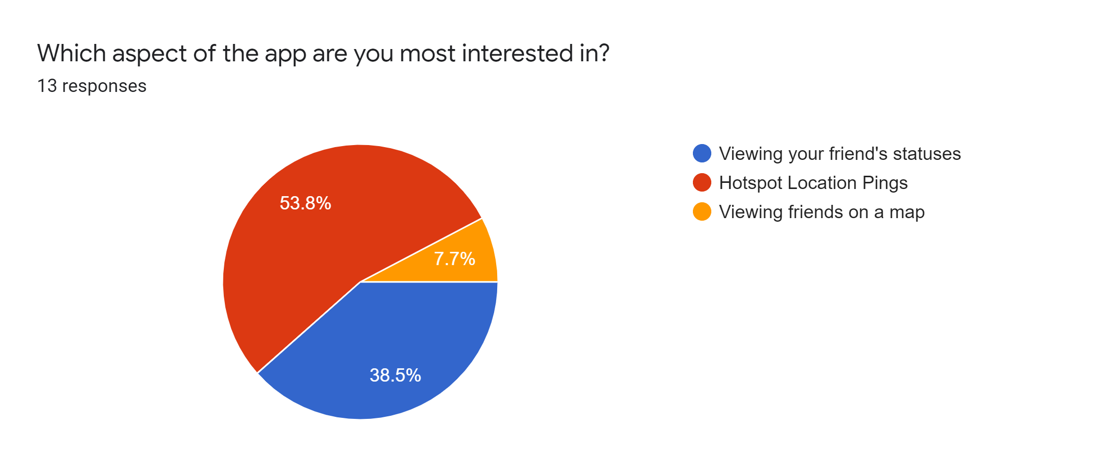

**Results of Primary Market Research Analysis**:

We found that the majority of our data came from CSULB students and college-aged participants, with the majority being 18-21, and the oldest being 28 (Third Bar Graph). Many of our participants gave feedback on their liked features, and which aspect of our app they would use the most (First Bar Graph, Pie Chart). We also polled the necessity of the implementation of direct messaging within the app, and many of those polled rated it as highly necessary (Second bar Graph). This further cemented our target market segment of young adults and college students. This Primary Market Research also helped us narrow down our choices for features we thought of and let us know what users liked more than others. Our poll was posed to Reddit at r/csulb and r/samplesize and the CSULB Student Discord to receive feedback. We plan to update primary market research with direct user feedback on implemented features and design of the app in further documentation. For user-written feedback, we received that users would love to filter their friends by status, and be able to change which friends they receive notifications for. They would also like the additional feature of “planning out” their time available by blocking out the times they are in class or work ahead of time, so that they won’t need to receive notifications from the app during those times they are busy.

**Secondary Market Research**

Location-based social media networks are platforms that implement GPS features which allow users to broadcast their location or interact with their surroundings dynamically. Also, they allow advertisers to market in new, unique ways, such as marketing certain products or services through the use of specific location-centric data or by knowing what’s around users at a particular point in time.

Any persona that has a desire to interact with people and their surroundings in a more dynamic way has a reason to use our social media platform. Since 2016, approximately 90% of smartphone users were found to keep the location services features of their phones on (Geomarketing). However, in a different survey on the same topic conducted by Skyhook, 83% of their respondents said that location-based services were crucial to their mobile experiences, but more than half of the respondents who use weather and navigation apps said they do not keep their devices geolocation features always turned on. What we can extract from this analysis is that users are more than likely not simply attracted to the standard location-based services themselves, rather they are attracted to what the services they use do with these location services. So, it is important for our application to have unique, engaging, and useful implementations of location-based services that will entice our user-base to want to continually use these services.

“The location-based services (LBS) market reached a market value of $23.74B in 2018, and will reach a market size of $157.34B in 2026 at a 27.1% compound annual growth rate (CAGR)” (Allied Market Research). The market for LBS is growing at a rapid, sustainable pace, which puts our service in a favorable market position. Furthermore, the number of social media users globally has grown by 9%, reaching a user-base of 3.484B, which is a stronger indication that we should pursue this application (Smart Insights). Not only is the LBS market growing, but the mobile application industry is growing at a very fast rate as well. The mobile application industry reached a market value of $58.7B in 2018, generated primarily by in-app purchases, in-app ads, and big data (BizzSmartz). Some of the most future-proof sections of the mobile application industry are social networks, utility, and productivity services, which puts our application in a very good place as it employs a mix of key elements from each of these three sections.

According to Statista, by 2021 over 72% of the population in the United States will own a smartphone. Almost all young people between the age of 18-24 have at least one smart device. Because of this, many colleges have released their own apps that help students get connected with their school and the students that go to that school in more personalized ways.

The following diagram depicts how location-based social media platforms have historically implemented key features that a typical persona would find useful or engaging:

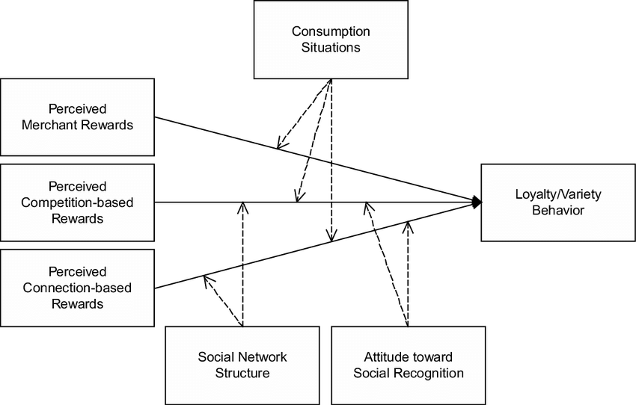

Fig.1 A stimulus-response model of location-based social network

There are many different social media types that exist in the current market. To get a sense of scope on the market as a whole, it is important that we briefly understand each and every major social media type. The various high level types of social media are: Social networks, media sharing networks, discussion forums, bookmarking & content curation, consumer review networks, blogging & publishing networks, social shopping networks, interest-based networks. In terms of platform architecture, each social media type has their own specified architecture, of course; however, when looking at social networks at a high level, each form of social media implements the following architectural layout:

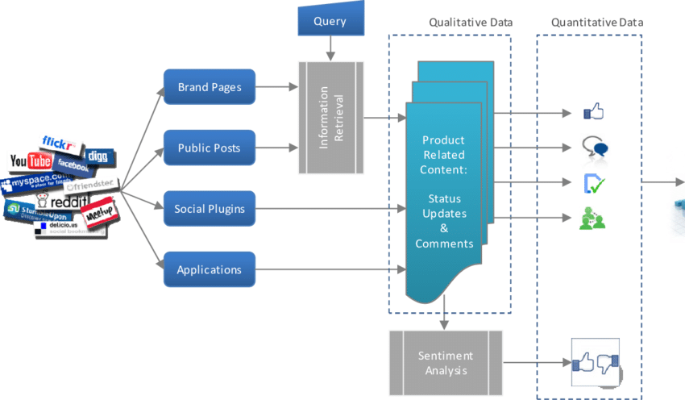

FIg.2 social network

**Case study: “Ask Around” App**

Release date: Match 4th, 2010

The function of this app uses your location to put you into a room with others using the app around you to have simple conversations. The app has a market size of 215M+ users. These users were found to ask 11,000 questions per minute. The users were being put into a chart room when they opened the app. The app would find other users who are near the user, usually around a hundred yards and up to 15 miles, which is set by the user. The user can also set a location on any place on a map to get the conversations around that location. Basically, the app has the ability to connect all the users who are using the app based on the location. The app allows users to post some short questions on a question board and wait for the surrounding user to answer the question. The question can only be looked at by the people at the location and answer it. This helps users to limit the range of who the user wants to converse and make the answer more accurate to the user. The user could also be anonymous to post, looking and answer the question. It helps people community with the people who are near to them. If the questioner and answer are both interesting to the question, it is easy for them to meet and become friends. This app helps people understand well about the location they are at.

**Data driven decisions**

Based on our research, we found that users have a need for checking their friends’ current statuses. From primary to secondary market research, students lack an easy way to communicate with each other passively short of instagram/snapchat stories. Based on our data regarding how often users utilize location-based services, we believe we should implement innovative features that take advantage of the power of location-based services. Users should feel the need to engage with the range of location-based features our app offers, as a typical user of this service will want information regarding their surroundings, friends, and how those two entities are interacting with each other at any given time. We know that our target age group of young people and college students is the age group that uses social media, across all forms, the most (Marketing Charts). Therefore, after gaining these insights from secondary market research in accordance with the results found from our primary market research, we decided that pursuing this app would prove to return strong results and garner lots of attention, with a viability in the market.

**User need**

The user need for this application is driven by our needs as busy college students. We have a constant personal need to see which of our friends is available on campus, in order to hang out, eat, study, or work out. We run into the constant issue of trying to text friends and ask where they are, or bothering an entire group chat when some are busy. This need is alleviated by this application, giving its users an accessible and efficient method of checking their friends’ statuses.

**Competitors**

**Foursquare**: Foursquare is a location-based social media that helps users discover and share information about businesses nearby. They can share information about their visit to a specific business and see information on other users visits.

**SnapMap**: Able to see local friends on a map interface, ability to message and “snap” friends, as well as location-based stories.

**Yik Yak**: Local area anonymous messaging similar to a local twitter, emphasis on college campuses, no longer in business.

**Discord**: Ability to set custom statuses and message, voice chat, create groups, and video chat with users. Anyone associated with a certain topic can receive notifications from one other user.

**Whrrl**: A location-based social media application used for story telling in different areas of the world. A user can check in at various locations and add a story about what they’re doing or have done there through pictures or simply text.

**SWOT Analysis**

|  |  |
| --- | --- |
| **Strengths** | **Weaknesses** |
| Our application will help bridge the gap between a student’s work life and their personal life. College students are busy, usually attending school full time (40 hours a week) and often working part time as well. This application will allow students to post their statuses of what they are doing currently, for example if they want to post that they are studying for an exam, they can update their status and say that they are busy studying and it will leave them on a do not disturb status. Additionally, once the student is finished with studying, and they want to set their status to available, it would notify other people that they are free and are available for leisure activities  Another strength with our application is that students can meet new people through the hotspot feature. The hotspot feature is used for pinging certain locations on the map that notifies other people of what events are happening around them. For example, if there is a job fair happening around them, a student can ping that location that lets other people know that there is a job fair at that location. Using the student’s location, it will also approximate events that occur around them. | One of the main weaknesses with our application is privacy. Since our application uses location data to locate students, and ping hotspots for events nearby. College students are concerned about protecting their privacy in the era of companies collecting data on their consumers. Our application will try to combat this to allow our consumers to reveal their location to certain people. In this way, they can have control of who gets to see their location on the map. For example, they can use this feature to allow only their friends to see their location. They could also have the ability to  Another weakness of our application is that this is very similar to other social media applications such as Facebook. Similarly, on Facebook a person can post a status online. They can like, comment, and share posts that their friends make. However, our application is more targeted towards college students. |
| **Opportunities** | **Threats** |
| According to our strengths, we could definitely expand more functionality within our application. We want to allow our application to be flexible and comfortable for our users. Allowing our users to have group chat functionality is a goal for the application. Having our users communicate with each other would be convenient and useful for them.  As members of our primary market segment, we know in depth of what our demographic wants, needs, and the problems we run into on a daily basis. This allows us as product owners and developers to be able to speak to our demographic easily and provide an insight while creating this application. | Our application is similar to other social media sites such as Facebook and Snapchat. Our application is similar to Facebook’s design for posting statuses and knowing what your friends are doing. After creating the status anyone that they have added as a friend can see the status. Since Facebook is a gigantic company it could overshadow our application.  Snapchat uses location data in one of their features called “Find my friends.” This allows people to see their friend’s location. It displays a map of the area and places their avatar according to their location information. |

**Appendix**

User Personas

|  |
| --- |
| Justina, The Struggling Student  Personal Background: Age 20, Single  Lifestyle: Full time student with a part time job.  Demeanor: Professional, Shy.  Challenges: Juggling between personal and professional lives, not knowing which friends are busy. |

|  |
| --- |
| Sean, The Frat BoyImage result for college student picture  Personal Background: Age 18, Single  Lifestyle: Full time student, part time job, in a fraternity  Demeanor: Casual, Outgoing  Challenges: Focusing on school due to fraternal commitments, meeting up with differing groups of friends. |

|  |
| --- |
| Tanger Hillel: A campus club/organization  Personal Background: Ages 18-22, Religious organization  Lifestyle: Full and part time students, commitment to organization events  Demeanor: Friendly, family/friend-oriented  Challenges: Focusing on organization commitments, meeting up with different groups of available friends within the organization. |

**Sources**

Formats*: (n.d.) Location-based Services (LBS) Market Statistics and Forecast - 2026. Retrieved from <https://www.alliedmarketresearch.com/location-based-services-market>

Carter, Joanna, and Gavin Llewellyn. “Global Social Media Research Summary 2019.” *Smart Insights*, 25 Oct. 2019, [www.smartinsights.com/social-media-marketing/social-media-strategy/new-global-social-media-research/](http://www.smartinsights.com/social-media-marketing/social-media-strategy/new-global-social-media-research/).

Holst, Arne. “Smartphone Penetration in the US 2010-2021.” *Statista*, 15 Nov. 2019, [www.statista.com/statistics/201183/forecast-of-smartphone-penetration-in-the-us/](http://www.statista.com/statistics/201183/forecast-of-smartphone-penetration-in-the-us/).

Tussyadiah, Lis. “A concept of location-based social media marketing.” ResearchGate, Apr. 2010<https://www.researchgate.net/figure/A-Stimulus-Response-Model-of-LSN-Marketing_fig1_254377712>

Siegler, MG. “An Unlikely Entrant In The Location App Race At SXSW: Ask.com.” *TechCrunch*, TechCrunch, 3 Mar. 2011, techcrunch.com/2011/03/03/ask-around-app/.

Kaplan, David, and David Kaplan. “Overwhelming Number Of Smartphone Users Keep Location Services Open.” *GeoMarketing by Yext*, 26 Apr. 2016, geomarketing.com/overwhelming-number-of-smartphone-users-keep-location-services-open.

“Social Networking Platforms' User Demographics Update 2019.” *Marketing Charts*, 22 Apr. 2019, www.marketingcharts.com/digital/social-media-108184.

Admin. “How Big Is Mobile App Industry?” *BizzSmartz*, 18 Mar. 2019, [www.bizzsmartz.com/how-big-is-mobile-app-industry/.](http://www.bizzsmartz.com/how-big-is-mobile-app-industry/.)

“The NCES Fast Facts Tool Provides Quick Answers to Many Education Questions (National Center for Education Statistics).” *National Center for Education Statistics (NCES) Home Page, a Part of the U.S. Department of Education*, nces.ed.gov/fastfacts/display.asp?id=372.